## Merchant

Demo date: Nov 4, 2024  
Scoping start date: Nov 19, 2024

MSA Signature Date: Dec 10, 2024  
Onboarding Kick Off Date: N/A

[If Exists] Opt Out Date: None  
Go Live Date:

GTM POC: Jarrett  
Implementation POC: Jeff

ERP: QBO

Tax Integration: No Tax

### 

### Key people at Merchant

### Finance and ops: Aayush Daftari https://www.linkedin.com/in/aayushdaftari

### 

### 

| Notes Sections [Ops International Team to Ignore] *(AE/ Implementation to fill)*   * **Info on how merchant bills: Usage via CVS** * **Pass-through Revenue:**   + For certain customers, they have a pass-through billing arrangement where costs incurred are directly passed on to the customer without any markup or additional calculation. This is straightforward, as the actual usage cost is billed as is. * **Fixed Limits with Overage Charges:**   + Some customers have predefined limits on their usage. If they exceed these limits, additional charges are applied based on the overage. This type of billing involves calculating standard usage up to a threshold and then applying extra fees for any excess usage beyond this set limit. * **Custom Logic for Specific Customers:**   + There are unique cases where certain customers have special billing arrangements due to legacy agreements or specific negotiated terms. For example, some customers might have custom exceptions where certain costs are not billed or adjusted based on predefined rules. This might include excluding specific charges or applying special discounts, requiring manual intervention. * **Customer count / volume?** 56 * **Usage: Is this billed monthly?** Yes * **Billing model: In arrears?** Yes * **Usage data files = They are good with uploading these themselves. Are they all standard across all his clients?** Yes * Our contact there says he fully expected to make manual adjustments on the invoice level to support point 3. * **Is there any important merchant relationship information?**   + He’s part of FOG could be used as a future reference * **What is the merchant temperament?**   + Very cool very laid back * **Is there a key POC: (i.e.: who is the buyer/decision maker?)** * Finance and ops: Aayush Daftari   **What are the Tabs features that the key POC cares about?**   * Usage billing, contract ingest, revenue reporting |
| --- |
|  |

### 

### Company summary *(AE to fill)*

**Summary of what company does:** AirOps lets you easily build and scale AI workflows to crush your growth targets. Build with 40+ AI models, retrieval, and data sources or launch one of our proven playbooks.

Goals (North star)  
*(AE/ Implementation to fill)*

**What is the merchant's goal? What pain are we solving? Why are they buying Tabs?**

The merchant has a PLG and B2B business with usage. They want to have a tool to streamline usage billing for their B2B segment. Tabs will not touch the PLG flow. Manual usage in spreadsheets

**Is there an opt out clause? If so, what is the merchant looking for so they do not exercise it?**

None

### Billing model *(AE/ Implementation to fill)*

* **Are there unique things about the customer creation process for this merchant?**
  + None- Customers should be expected to come from contract. Sometimes, they have PLG customers that graduate to the classic b2b billing.
* **Information on how merchant bills**
  + See above
* **How contract is broken up**
  + N/A (Contract examples in Garage)
* **One-off things to know about the merchant**
  + **They use a affiliate platform called Rewardful that leverages stripe** 
    - **Merchant’s overview:** We have Builders (lets say like Influencers) who get a 20% commission for referrals that stay beyond 30 days. They are setup in a system called Rewardful. Currently we have 4 enterprises with the Rewardful process. One of them just converted from a self-serve/PLG user to an enterprise. Hoping to keep this low but we can definitely see a few conversions every 6 months. Its a mix between Credit Card or ACH. Just depends on size of invoice (if its smaller then they do CC, otherwise bigger invoices are ACH)
      * Process flow:
* Builder is setup in Rewardful and has a coupon code attached to them
* New enterprise customer that is referred by them is setup by me
* During customer setup, i enter the rewardful code in stripe as metadata
* Whenever the customer pays an invoice, it registers in rewardful and aggregates the amount to be paid
* End of month, i see the total commission payout and then paypal them money
  + - * **Our Recommendation:** When we send an invoice to a customer with CC and ACH debit enabled, it will automatically create a customer record for them in Stripe. On that customer record, you should be able to append the Rewardful code to their metadata, and the official payment tracking will work just as it does today.
        + For your 1 or 2 customers currently paying via ACH credit, we have a couple of options:

1. Maintain the Rewardful flow by having them switch to paying via credit card or ACH debit.
2. Tag every Rewardful customer in Tabs with a custom field and generate a report for you. This will allow you to track payments from Rewardful customers, and you can disburse those funds in any way you'd like.

### Contract Processing Steps *(Implementation/Success to fill)*

1. Steps to process
   1. Customer Creation
      1. All customers were created already - customer name can be found in opening paragraph on contract and document name
      2. If no customer has been created already, please create
   2. Term length
      1. Found in the first paragraph of contracts titled “Term”. Term length used for both billing and revenue schedules
   3. Effective date
      1. Use latest date of signature
         1. If no signature date - use date in contract name
   4. Item names
      1. Platform Fees for software subscription component
      2. Additional Tasks for usage component
   5. Integration Items
      1. Follow mapping here: [AirOps | Integration Items](https://docs.google.com/spreadsheets/d/1H5eKZ4r9cAMEHilLGA3Vo22KnK0CeBDWW8cf9iUdb5I/edit?gid=0#gid=0)
         1. **AirOps Platform (14)**
         2. **AirOps Professional Services (53)**
   6. Pricing and billing cadence
      1. Found within section 2. Pricing
      2. Calibrate subscription fees as flat price and usage fees as unit price
   7. Additional Tasks
      1. If you see additional tasks in the order form

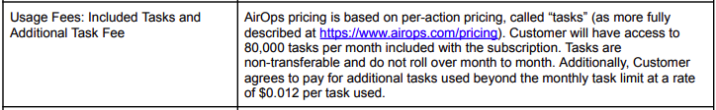

* + 1. This product should be created for all new customers by default
    2. Usage BT for $1. Example below
       1. Event is Additional Tasks
       2. It should start at the beginning of the month of the start date (if contract start date is 6/20, this product should start on 6/1)
       3. Integration item: Additional Tasks (**the one that has 52 other relations in the dropdown** and not the one it selects right now which merchant believes is the December 2023 item)

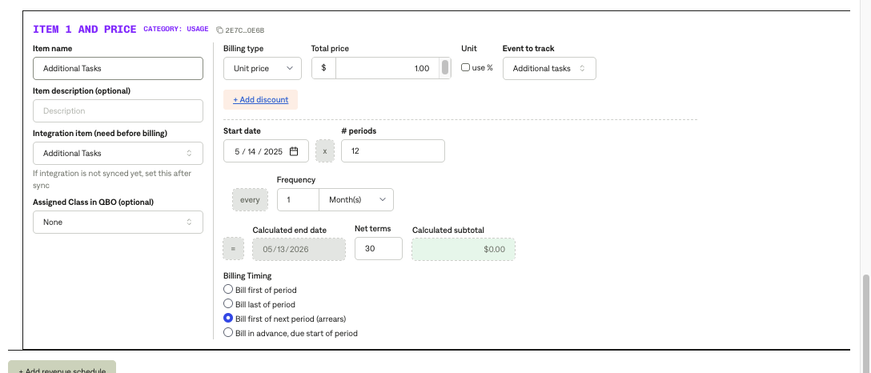

* 1. Net Terms
     1. Found in Section 4. Payment Terms››
     2. If not found, default to net 30

1. Anything to ignore in contracts?
   1. Everything in MSA after signature - just legalese
   2. **Ignore all usage terms except Additional Tasks**
2. Specifics processing things the merchant has requested that may differ by contract (e.g. always back-date invoice date to final day of the month)

N/A

1. Default Service Term
   1. If None Listed, Ops Default is 1 Year
      1. Can find in Section 1. Term
2. Default Net Payment Terms
   1. If None, Ops Default is 0
      1. See section 1. Steps to process
3. Default Billing Frequency
   1. If None Listed, Ops Default is Monthly
      1. Found in section 2. Pricing
4. How do we handle taxes as a line item?
   1. If None Listed, Ops Default is every tax line item becomes a BT
      1. No taxes

### Events Processing (if necessary) *(Implementation/Success to fill)*

* Any important information on events billing
  + Only usage type is tasks
  + Rate is often displayed in terms of 1000 tasks
    - In this case, divide price/tasks to get unit price and use that value in Garage
      * I.e: [Findings](https://garage.tabsplatform.com/prod/contracts/03edd247-36e0-4f4d-b260-72630e37f792/terms/revenue)
      * Rate = $5/1000 tasks
      * Garage price = .005/task

Integration Items Processing (if necessary)  
*(Implementation/Success to fill)*

* What are the instructions for assigning integration items?

[AirOps | Integration Items](https://docs.google.com/spreadsheets/d/1H5eKZ4r9cAMEHilLGA3Vo22KnK0CeBDWW8cf9iUdb5I/edit?gid=0#gid=0)

Post Processing Communications (if necessary)  
*(Implementation/Success to fill)*

* Does the Ops Team need to notify anyone on the team re: completion of processing batches in Implementation or Active phase?
  + Notify [Jeff Kurzman](mailto:jeff@tabsplatform.com) when batch processing is complete
* Who needs to be notified and when?
  + Example:
    - Who: Customer Success [Azmat Aziz] needs to be notified
    - Where: Messari internal merchant channel
    - When: contracts are processed [Merchant Phase: Active]

### Customer Information *(Implementation/Success to fill)*

* Any important information on specifics customers of this merchant
  + Special memo’s certain invoices require
  + Invoice changes due to merchant/customer relationship

### Feature Requests *(AE/Implementation/Success to fill)*

* FR 1
  + What is it
  + Why it's important
  + Urgency

### Rewatch Calls *(AE/Implementation/Success to fill)*

* <https://tabs.rewatch.com/video/3cfpghbb08bukpdx-airops-sandbox-walkthrough-december-4-2024>
* <https://tabs.rewatch.com/video/3himxdvjj8tjrc1g-aayush-tabs-scoping-follow-up-november-27-2024>
* <https://tabs.rewatch.com/video/kd894vy5o1r7o3hc-jarrett-tabs-aayush-november-12-2024>
* https://tabs.rewatch.com/video/nknwthislaqwq9rj-jarrett-tabs-aayush-november-5-2024